PhenoMiner User Submission Help Document
This document is intended to help users through the process of submitting data to the Rat Genome Database’s (RGD) PhenoMiner. Some fields are required, while other fields are optional but highly recommended. These optional fields add helpful information that will allow the Curators to accurately map the data to the correct term/measurement. Please upload your protocol/methods for experiment.

Step 1--Submission Info Form (found on Experiment & Submitter Info tab)
Download and fill out form with experiment information (1.). Fill in the contact information for the Principal Investigator/Lab (2.) as well as the Submitter in case of questions. The fields are marked either required or recommended. The Gender and Individual/Summary Data fields have drop down boxes to make your choice easier. You will find links to the Strain Search Page and Strain Query Form at the bottom of the form (3.). If you can’t find your strain on the RGD website strain list or would like to register a new strain visit http://rgd.mcw.edu/tools/strains/strainRegistrationIndex.cgi to find the online registration form. If data were collected from a new stain, please register your strain prior to submitting phenotype data. Please contact RGD with any questions about the data load (4.).
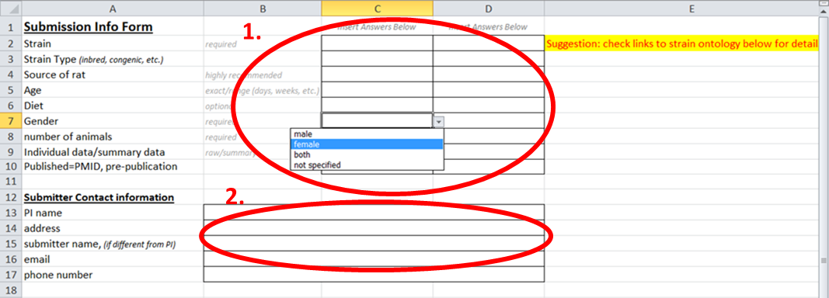

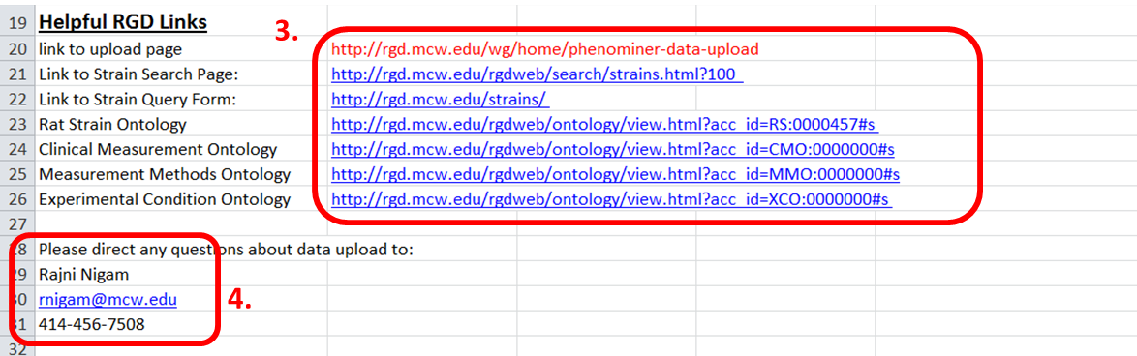

Step 2--Data Submission

Summary Data Load: Found on Summary Phenotype Data tab
Examples of data are provided in greyed-out rows. (1.) Please do not put your data in the grey rows. Enter data starting in Row 5. Enter Clinical Measurement (required)(2.) Clinical Measurements Ontology ID (optional) Click Colum Header to go to Clinical Measurement Ontology (3.). Clinical Measurements are Phenotypes that are measured by an experiment. Examples: heart rate, blood cell count, serum total cholesterol level. Enter the units for the Clinical Measurement previously chosen (required) (4.) If term is not available please email RGD.DATA@mcw.edu to register a new term or ask for suggestions
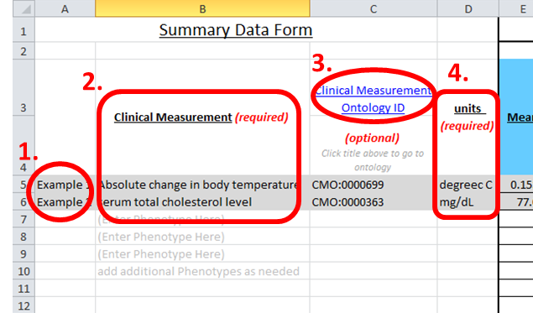

Enter the Strain for each group of measurements (5.) This template is created with space for 3 groups (6.).
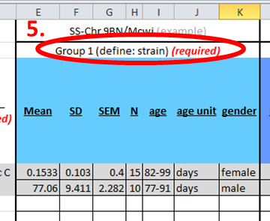

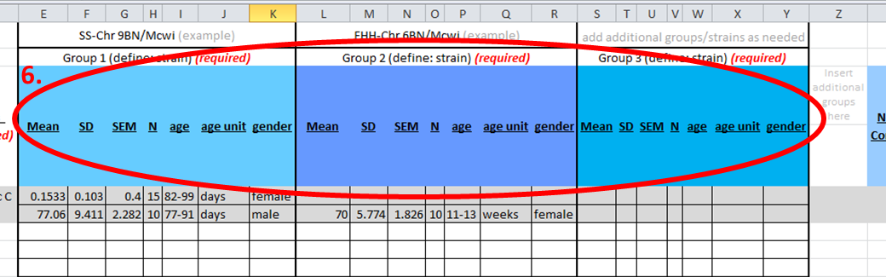
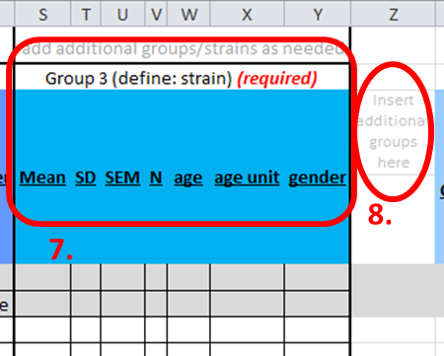

If your study/experiment has more than 3 groups, copy the 7 columns that make up a group (7.) and insert copied columns as needed in column Z. (8.)

Entering Data for each group. (9.) Please enter the mean for each group. Enter the Standard Deviation and/or the Standard Error for the group. We need at least one of these measurements to graph the results. Enter the number of animals for each group. Next, enter the age of the animals at the time of the measurement. Please include the age unit (ex. Days, weeks, months).
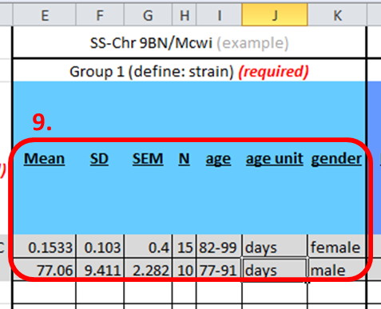

Enter Measurement Method (required) (10.) Measurement Method Ontology ID (optional) (click on column header to go to the Measurement Method Ontology. Enter Measurement Method Site (optional). A Measurement Method describes how the individual phenotype was obtained. Examples: fluid filled catheter, blood chemistry panel, radiotelemetry, radioimmunoassay, etc.
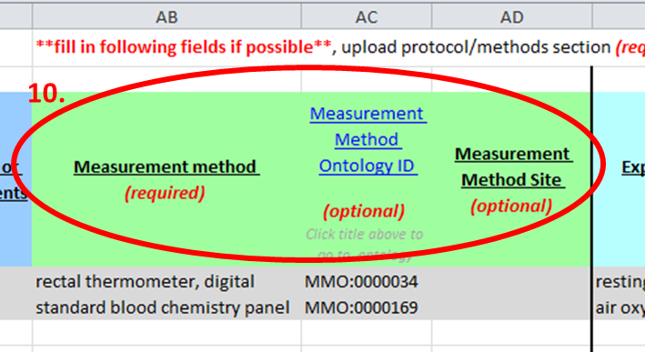

Enter Experimental Condition 1 (required) (11.) Experimental Condition 1 Ontology ID (optional). The Experimental Method describes the conditions of the experiment both before and during the measurement. Examples: diet, atmosphere composition, activity level, etc. Click on Condition Ontology ID column header to go to Clinical Condition Ontology.

Enter Experimental Condition 1 Value (optional) (12.) and Experimental Condition Length/Duration (required).
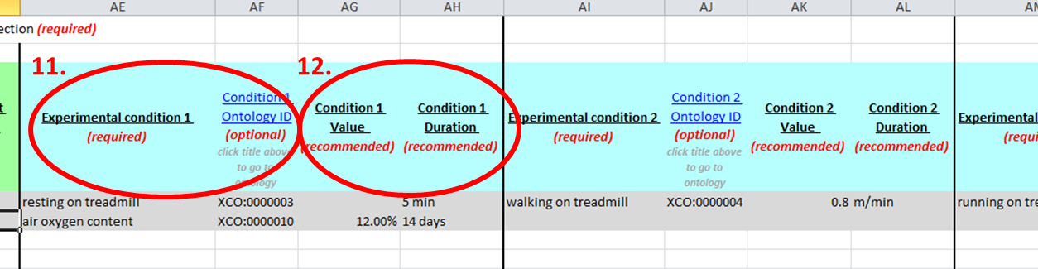

Continue to add experimental conditions as above. The template has space for 4 different Experimental Conditions but more Conditions/columns may be added as needed.

Individual Data Load: Found on Individual Data Load Tab

Examples of Data are provided in greyed-out rows. (1.) Please do not put your data in the grey rows. Enter Clinical Measurement (required) (2.) Clinical Measurements Ontology ID (optional) Click on the Clinical Measurement Ontology Id column header to go to the Clinical Measurement Ontology.
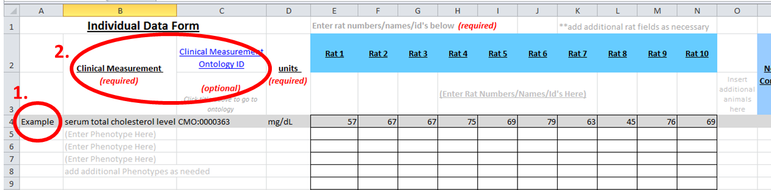

Enter the units for the Clinical Measurement previously chosen (required) (3.) Enter Rat Numbers/Names/ID’s (required)(4.) Additional Rat Fields can be added as necessary (5.)
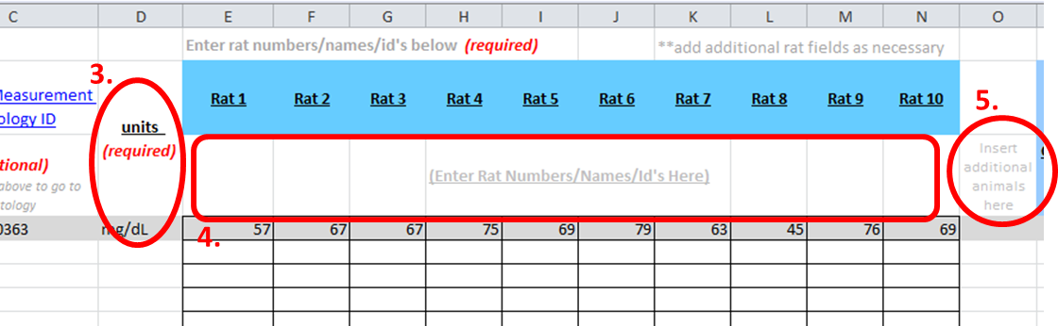

Enter Measurement Method (required) (6.) Measurement Method Ontology ID (optional)
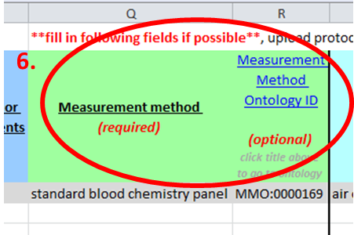

Enter Experimental Condition 1 (required) (7.) Experimental Condition 1 Ontology ID (optional). Enter Experimental Condition 1 Value (optional) (8.) and Experimental Condition Length/Duration (required).
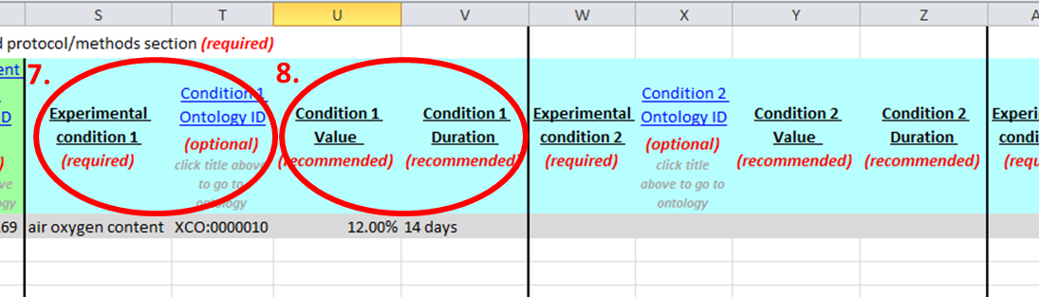

Continue to add experimental conditions as above. The template has space for 4 different Experimental Conditions but more Conditions/columns may be added as needed.

Saving Instructions

Save file with the following format:

PI name_experiment_date submitted

Example: Smith_high salt blood pressure_5-12-12

